### **Daylighting Controls**

### Author

* Supriya Goel, PNNL (design)
* Andrew Parker, NREL (coding)

### Description[1]

Daylighting controls are used to dim the electric lighting when sunlight provides adequate lighting levels in the space. The design of a daylight harvesting system should account for sensor location, sensor orientation, and number of sensors. During installation, the light sensitivity settings should be adjusted so that the desired lighting level is maintained in the space. Also, the system should be tested for proper functionality. Dimmable ballasts are typically also required as part of a daylighting strategy.

### Modeler Description

Loop through each zone in the baseline model. If the zone does not have toplighting or sidelighting control, add daylight sensors per 90.1-2010 9.4.1.4 and 9.4.1.5, with a target illuminance of 300 lux. The fraction of lighting controlled by the daylighting controls is determined based on the ratio of the daylighted areas to the total floor area. If the zone already has daylighting controls, skip this zone.

### Code Outline

The measure checks for the baseline condition and modified the recommended model as specified below.

1. Identify Applicable Zones
   * 1. Applicable zones
        1. Zones with skylights/windows
        2. Zones without toplighting or sidelighting controls
        3. Toplight Daylight Area exceeds 900 sq.ft, except climate zone 8 where daylight area should exceed 1500 sq.ft (exception c to 90.1 2010 Section 9.4.1.5)
        4. Sidelight daylight area exceeds 250 sq.ft
     2. Identify use type of the applicable zones.
     3. Identify Ceiling Height (CH) of the applicable zone with skylight
     4. Identify sill height and window dimensions of applicable zone with windows
2. Toplight Area: Definition

In accordance to ASHRAE Standard 90.1 2010 the daylight area under each skylight is bounded by the opening beneath the skylight, plus horizontally in each direction, the smallest of

* 1. 70% of the ceiling height (0.7 × *CH*), or
  2. the distance to any primary sidelighted area (Not Applicable to Asset Score)
  3. daylight area under rooftop monitors (Not Applicable to Asset Score)
  4. the distance to the front face of any vertical obstruction where any part of the obstruction is farther away than 70% of the distance between the top of the obstruction and the ceiling (0.7 × [CH– OH]), where *CH* = the height of the ceiling at the lowest edge of the skylight, and *OH* = the height to the top of the obstruction

(Not Applicable to Asset Score)

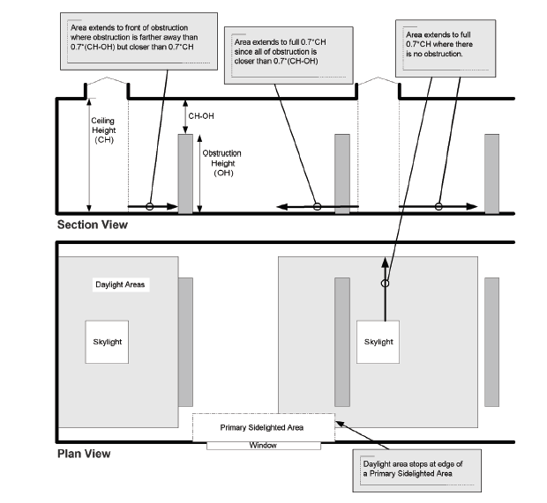

$$Toplight Area=({Skylight Length}_{x}+(2 X 0.7 X CH))×{(Skylight Width+(2 X 0.7 X CH))}_{x}$$

1. Sidelight Area : Definition

The primary daylight area for sidelighting is a band near the window with a depth equal to the distance from the floor to the top of the window and width equal to window width plus 2 ft on each side of the window opening.

Daylighting controls for secondary sidelight areas will not be modeled for the purpose of Asset Score.

$Sidelight Area=({Fenerstration Length}_{x}+4)×{Daylight Area Depth}_{x}$

$${Sidelight Area Depth}_{x}={Fenerstration Height}_{x}+{Sill Height}_{x }$$

1. Overlapping Areas

Double counting due to overlaps is not permitted. If a zone qualifies for both toplighting and sidelighting control, the toplighted area would take precedence, followed by the primary sidelighted areas.

1. Toplighting Sensor Location

For each daylight area associated with skylights, a single photosensor will be modeled to be located at the center of the width of the skylight, at a height of 3 ft above the floor.

1. Sidelighting Sensor Location

For each daylight area associated with vertical fenestration, a single photosensor will be modeled to be located at the center of the width of the daylight area (i.e., the window length), at the full depth of the daylight area and at a height of 3 ft above the floor.

#### **Rules**

* + - 1. The following steps shall be followed for determining the reference positions.
         1. Determine all non-overlapping daylit areas in a space. Double counting due to overlaps is not permitted. If there is an overlap between sidelight or toplight areas, the toplighted areas takes precedence, followed by the primary sidelighted area. Due to the difficulty in calculation of overlapping areas in AS, if a zone qualifies for both toplighting and sidelighting, toplighting controls take precedence and sidelighting controls are not added.
         2. For each daylit area (excluding overlapping areas) locate Reference position 1 in daylit space in following order of priority-

Toplight area under skylights

Primary daylit area in the South

Primary daylit area in the West

Primary daylit area in the East

Primary daylit area in the North

* + - * 1. Daylighting controls are not required for secondary daylighted areas for Asset Score.
        2. Locate Reference point 2 in the toplighted or primary area next in the order of priority defined in step 2. If there are no more toplighted or primary sidelit areas, the second reference point is not used.
        3. For non-cardinal direction facing areas, the following orientation logic can be used:

Windows facing between 315 degrees and 45 degrees –North

Windows facing between 135 degrees and 45 degrees- East

Windows facing between 135 degrees and 225 degrees – South

Windows facing between 315 degrees and 225 degrees – West.

* + - 1. Fraction of Zone Controlled Lighting

100% of the lighting within the daylit area of a zone would be modeled with lighting controls. Fraction of Zone Controlled Lighting is defined as the fraction of the zone’s floor-area whose electric lighting is controlled by the daylight illuminance at the First or second Reference Point. If there is only one reference point then the fraction of zone controlled lighting is equal to:

[1.0 - (Fraction of Zone Controlled by First Reference Point)]

is assumed to have no lighting control.

1. If there are 2 reference points-

Area with No Lighting Control = 1 – ([Fraction of Zone Controlled by First Reference Point] + [Fraction of Zone Controlled by Second Reference Point])

1. Daylighting Control Type

Daylighting control will be modeled as stepped lighting control. The electric power input and light output vary in discrete, equally spaced steps. The number of steps (Excluding Off) of Stepped Control and would be equal to 3.

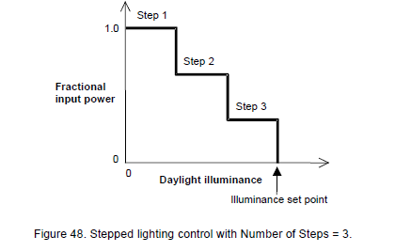

1. Target Illuminance Level = 300 Lux for all zones.

### EnergyPlus Example Input: Sidelighting and Top lighting Control

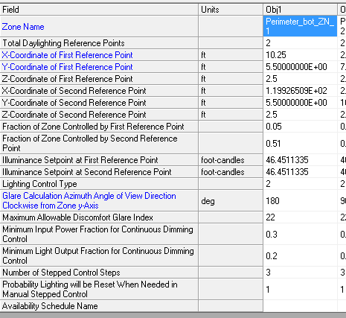

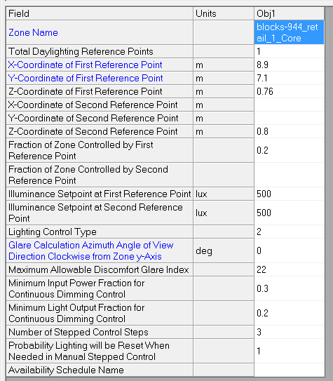

### Additional XML data

### Use Case Types

Retrofit, New Construction

### Class

### Arguments

“run_measure” is a choice argument that determines whether or not the Measure is applied during a given run.

### Initial Condition

### Final Condition

### Not Applicable Messages

### Information Messages

Describe the daylighted areas for each zone and whether or not daylighting controls are applicable to that zone.

### Warning Messages

Warn if the measure encounters non-rectangular windows or skylights, non-vertical walls, non-horizontal roofs, if fenestration VLT cannot be determined.

### Error Messages

If a space isn’t part of a zone, if daylight areas cannot be determined, or if a space has no floor.

### Code Outline

Too complex to describe here.

### Tests

|  |  |  |  |  |
| --- | --- | --- | --- | --- |
| Building ID | Building Description | Test Description | Expected Output |  |
| For All Tests- Expected output includes | | | Warning message if unmet load hours >300  JSON snippet identifying block IDs where Toplighting/sidelighting controls were added | |
| 1377 | Multi-Block Building,   * Core Retail block with skylights, no toplighting control * Remaining blocks with windows, no daylighting controls | * Verify that toplighting controls added * Also verify that no sidelighting controls are added to this block * No changes to Point of Sale and Front Retail block(daylight area <250sq.ft ) | OSM with toplighting control added to Core Retail Block | This test checks for   * Toplighting gets precedence over sidelighting * Sidelighting area limit of 250 sq.ft |
| 1378 | Multi-Block Building,   * Core Retail (2 flors) block with skylights, no toplighting control. And no sidelighting control in lower floor * Remaining blocks with windows, no daylighting controls | * Verify that toplighting controls added to Core Retail top floor * Also verify that sidelighting controls are added to the lower floor of Core Retail Block * No changes to Point of Sale and Front Retail block(daylight area <250sq.ft ) | * OSM with toplighting control added to Core Retail Block. * Sidelighting control added to lower floor of core retail block | This test checks for   * Toplighting gets precedence over sidelighting * All zones of a block are verified for eligibility * Sidelighting area limit of 250 sq.ft |
| 1379 | Multi-Block Building,   * Core Retail (2 floors) block with skylights, and toplighting control control. And no sidelighting control in lower floor * Remaining blocks with windows, no daylighting controls | * Verify that no additional controls are added to top floor of Core Retail block * Also verify that sidelighting controls are added to the lower floor of Core Retail Block * No changes to Point of Sale and Front Retail block(daylight area <250sq.ft ) | * OSM with no changes to top floor of Core Retail Block * Sidelighting controls are added to lower floor of Core Retail Block * No Changes to Point of Sale and Front Retail block | This Checks for  - All zones of a block are verified for sidelighting/top lighting eligibility |
| 1056 | Single zone small office building with 45% WWR on all surfaces and 3% roof area as skylights | * Verify total daylight area calculation * Verify that toplighting controls are added | * OSM with toplighting control added |  |
| 1056_2 | Single zone small office building with 10% WWR on all surfaces and 3% roof area as skylights | * Verify calculation of total daylight area and fraction of zone controlled by lighting controls | * OSM with toplighting control added |  |
| 1447 | Single zone small office building with 80% WWR on all surfaces and 3% roof area as skylights | * Verify calculation of total daylight area and fraction of zone controlled by lighting controls | * OSM with toplighting control added |  |
| 1448 | Single zone small office building with 45% WWR on all surfaces and 12% roof area as skylights | * Verify calculation of total daylight area and fraction of zone controlled by lighting controls | * In this case there is no overlapping between sidelit and toplight. * There is overlapping between sidelit areas of different orientations * Fraction of zone controlled should be =0.65 |  |

### Reference

Analysis for Retail Stand Alone Prototype (ASHRAE 90.1-2010, Chicago)

|  |  |  |  |  |  |  |  |  |  |  |
| --- | --- | --- | --- | --- | --- | --- | --- | --- | --- | --- |
| IDF Name | Description | No. of Sensors | First Reference Point (m) | | | Second Reference Point (m) | | |  | Notes |
| x | y | z | x | y | z | Site EUI (MJ/m2) |  |
| V1_WithoutTopLighting |  |  | NA | NA | NA | NA | NA | NA | 647.7 |  |
| V1 | Original Prototype with Skylights and Toplighting Control. | 2 Sensors | 14.2 | 14.2 | 0 | 3.4 | 14.2 | 0 | 632.82 |  |
| V1_RefPoint | Modified with 1 Reference Point, located in center of toplight area | 1 Sensor | 14.2 | 14.2 | 0.76 | 0 | 0 | 0 | 629.36 | overestimates savings |
| V1_RefPoint2 | Modified with 1 Reference Point, located at rear end of toplight area | 2 Sensor | 14.2 | 28.3 | 0.76 | 0 | 0 | 0 | 634.46 |  |
| V1_RefPoint3 | Modified with 1 Reference Point, located at 1/4 distance from front | 3 Sensor | 3.4 | 14.2 | 0.76 | 0 | 0 | 0 | 634.82 | Sensor location On the conservative side |

Analysis for Retail Stand Alone SEED Model

|  |  |  |
| --- | --- | --- |
| **Core Zone Dimensions** |  |  |
| L | 178 | ft |
| W | 96 | ft |
| Ceiling Height | 20 | ft |
| Skylight Area | 3% |  |
|  | 512.64 |  |
| **Skylight Aspect Ratio** | 1.854166667 |  |
| Skylight Dimentions |  |  |
| L | 30.83050437 |  |
| W | 16.62768775 |  |
| Area | 512.64 |  |
| **Toplight Area** |  |  |
| Toplight Area L | 58.8 |  |
| Toplight Area W | 44.6 |  |

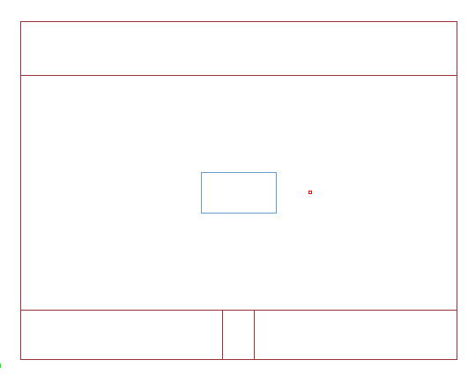

x,y,z (-27,-13.7,0)

x,y,z (-27,28,0)

x,y,z (27,28,0)

x,y,z (27,-13.7,0)

|  |  |  |  |  |  |  |  |  |  |  |
| --- | --- | --- | --- | --- | --- | --- | --- | --- | --- | --- |
| IDF Name | Description | No. of Sensors | First Reference Point (m) | | | Second Reference Point (m) | | |  |  |
| x | y | z | x | y | z | Site EUI (MJ/m2) |  |
| V1 | Original seed model- no skylights | no sensor | NA | NA | NA | NA | NA | NA | 827.81 |  |
| V2 | With skylights | no sensor | NA | NA | NA | NA | NA | NA | 859.19 |  |
| V3 | With Skylights and Toplighting control | one sensor | 14.2 | 7.01 | 0.8 | NA | NA | NA | 829 | incorrect location |
| V4 | With Skylights and Toplighting control | one sensor | 0 | 7.1 | 0.8 | NA | NA | NA | 810 | Center of the skylight-overestimates savings |
| V5 | With Skylights and Toplighting control | one sensor | 8.9 | 7.1 | 0.8 | NA | NA | NA | 812.86 | X=rear end of daylight area |

1. AERG- Office Buildings